Tutorial Guide to COUGAAR Agent Workbench

Installation

Working with COUGAAR Configurations
Every COUGAAR society can be constructed from an XML file that is simply structured.
A society XML file can be completely constructed using the AWB and its Society Editor and Rules-based Editor, but in this section we will cover elements of a society.xml file as a useful reference.

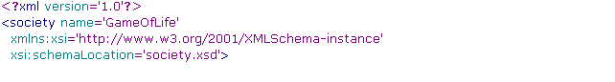
Society: Figure AA shows the encapsulation of elements in a COUGAAR society xml description, and Figure BB shows a typical XML file used to describe a COUGAAR society (the Game of Life society is shown). From Figure A, we can see that the outermost XML tag is the ‘society’ tag:

Although there are required attributes, the only one which is used by the COUGAAR society bootstrapper is the ‘name’ attribute, in this case the string ‘GameOfLife’. A society tag may encompass one or most ‘host’ tags. The current incarnation of AWB only services societies with a single host, but this may change in future.

Host: The ‘host’ tag has a single attribute, a string that must be specified as ‘name’, as shown in the next code snippet:

The value the attribute can (at this writing) be any synonym for ‘localhost’ valid in the /etc/hosts file (or its equivalent on other operating systems).

Node: The ‘host’ tag may contain any (reasonable) number of child ‘node’ tags. What is ‘reasonable’ depends upon the compute power and amount of memory on your target host, as each ‘node’ tag represents a Java VM. The Society Controller, another application bundled as a part of the AWB, can start and stop a COUGAAR society specified in a society.xml file. On startup, each node specified will become an individual JVM. The ‘node’ tag has a single attribute, which is also called ‘name.’ The ‘node’ tag can have several child nodes, which we now describe. This xml stanza shows a typical set of child nodes:

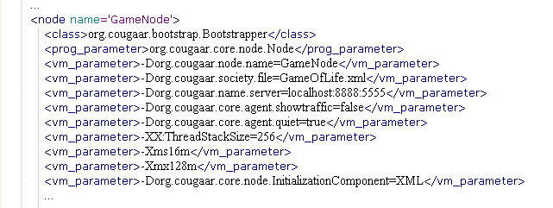
The ‘class’ element specifies a Java class, normally the fully qualified package name of the COUGAAR bootstrapper. It should be found in the folder pointed to by the environmental variable COUGAAR_INSTALL_PATH. Also shown are specifications for prog_parameter and vm_parameter. These are passed directly to the bootstrapper as runtime parameters.

Agent: The ‘node’ tag may contain one or more ‘agent’ tags. A node (which as we stated previously is a synonym for a VM instance) can support a number of COUGAAR agents. The number of agents varies according to a number of factors such as compute capacity, memory, functional design, systems architecture. The Game of Life Society associated with the AWB tutorial contains a Game Manager Agent and several agents representing the various cells in the game.
Here is an XML stanza representing an agent from the Game of Life implementation.
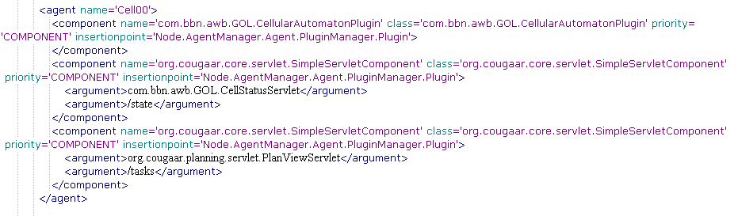
Notice that ‘agent’ can have a number of ‘component’ stanzas and those in turn can have a number of qualifying ‘argument’ stanzas. In this instance, one of the Game Of Life Cells (Cell [0,0]) is being specified. It is comprised of several Plugin components, namely the CellularAutomatonPlugin, the CellStatusServlet, and the PlanViewServlet. Two of these plugin components have arguments which are used at plugin load time to further customize the plugin. In this case, a URL qualifier is being added to the two servlets.

The Big Picture
When we look at a society xml file graphically, it could be represented as shown in the foillowing figure:

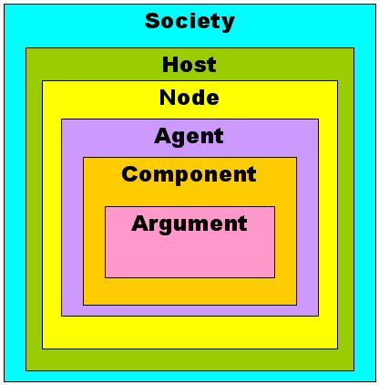
The society XML file is fairly simple and has a finite number of sub-elements. Additional sub-elements might conceivably be added at a given level, however the structure and substance of the specification file has proven relatively ‘roadworthy’ for a number of COUGAAR based application spaces.

Working the Elements of the Agent Workbench
One could create and launch a COUGAAR society by hand-editing the file documented above. Alternatively, a GUI-based editor and controller might be more useful and user friendly. Toward this goal, the Agent Workbench (AWB) was created. AWB has several working panes. In this document, we strive to explain the function of each of them at a fairly high level in hopes that it will encourage experimentation.

The next Figure shows the basic GUI framework of AWB. There is a Society Editor which is used for basic editing of a society. With the Society Editor , one can create a society from scratch using just its capabilities.

Society Editor

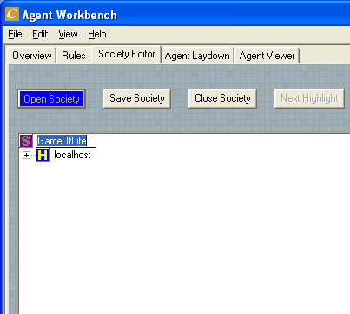
Using Society Editor to create a society by hand, one would first create a society from the File→ New menu and then change its name to one that’s descriptive. You can do that by right clicking the society name as shown in the following figure:

.

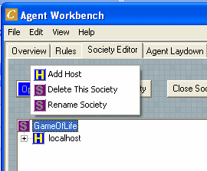
You can add elements from the right click context menu ad lib. The editor won’t let you add anything that is inappropriate to the level you have left-clicked on. Thus, if you left click on a the society element, you can only add / delete the society and all its sub-elements or add a host:

When left clicked on a host, you can do things appropriate to that level, like so:

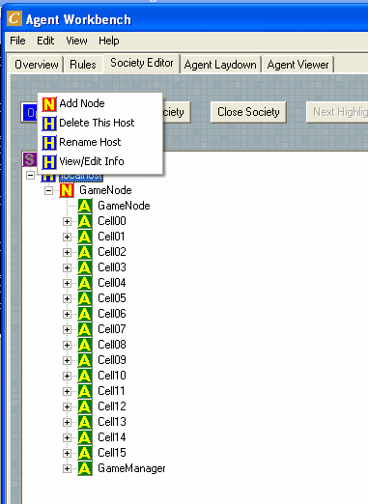
Here, we have left clicked on a host and the options are relevant only to the host level.
When you have fully defined a society to the level of detail such that it will run, save the society for example as “mysociety.xml”

In the sample society shipped with AWB, shown above, we have defined a 4 by 4 grid. The game manager understands the Game of Life to be a row major layout, with cells numbered [(0,0), (0,1) and so on.

Using the next tool we will discuss, the Rules Editor, will demonstrate suing rules to add cells and tailor the society.

Rules Editor
Certainly, you could manually add more cells and do additional tailoring, but using the Rules Editor, you can substantially lower the work effort.
To use the Rules Editor, you should switch to that panel, open a society and open a set of rules. A society may be one that you have created by hand using the Society Editor, and rules may be any folder containing snippets of Python code useful in transforming a COUGAAR Society model. The API for the COUGAAR Society Model is delivered with the document set for AWB. Samples transformation rules are delivered with the Game of Life Society. There are rules relevant to the Game of Life. Shown below is one that increases the size of the game board to a ten by ten matrix.
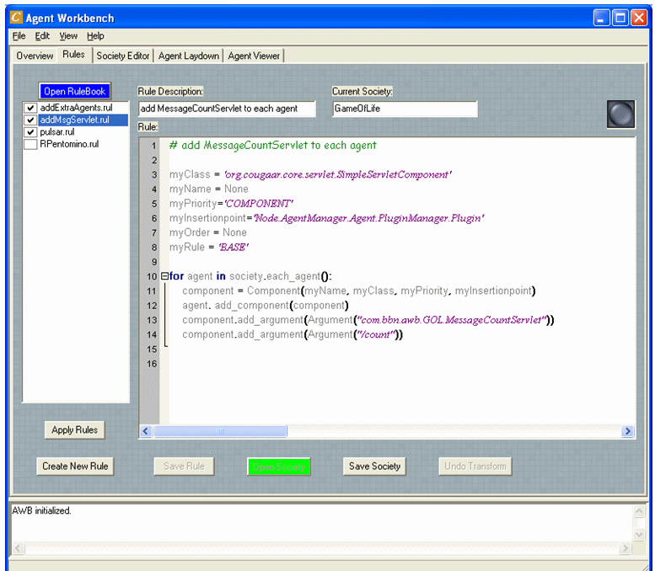

The method addNewArgs(component) tells the Game Manager there are now 10 rows in the game. It does this by finding an argument starting with the name ‘rows=’ and deleting the old argument then inserting a new one with the value ‘rows=10’. The only agent with this argument is the GameManager.

Next, the GameManager is located and its component is populated with additional arguments whose initial value is set to ‘dead’ or ‘off’. Lines 8 – 9.
The GameManager is located and the component is overwritten (lines 11-16). Finally, new agents are added (lines 18-26). This demonstrates the power of rule-based society manipulation over manual editing.

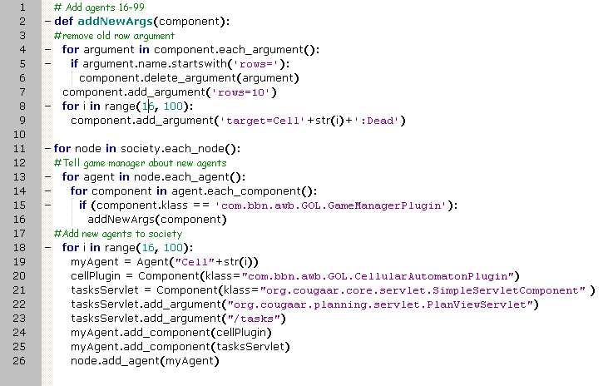
Figure 1 - AddExtraAgents rule
Another rule supplied with the Game of Life sample application is called the add Message Servlet rule (c.f. in addMsgServlet.rul):

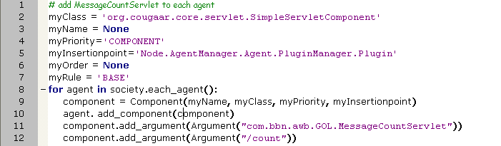
This rule adds a servlet (which has been coded and is part of the Game of Life sample application) to every agent. First a few variables are defined and then for each agent in the society, the appropriate servlet is added (lines 8-12). Again, this demonstrates the power of rule-based society manipulation over manual additions.

A Final rule sets initial values for game pieces, which in the Game of Life can be set to dead or alive initially. Here a simple array of game cells is specified as being ‘alive’ (lines 4-5) and later the game Manager is informed with the knowledge of which cells to start out as alive (lines 22-23).

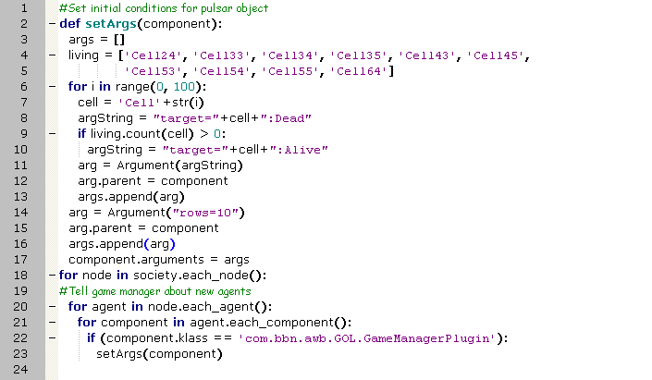
The Rule Editor enables you to create new rules with a syntax sensitive editor and save them into a collection of rules (files ending with the file extension ‘.rul’). These can be tried out against the society in memory and that society saved as modified.

Society Laydown Editor
This section is TBD.
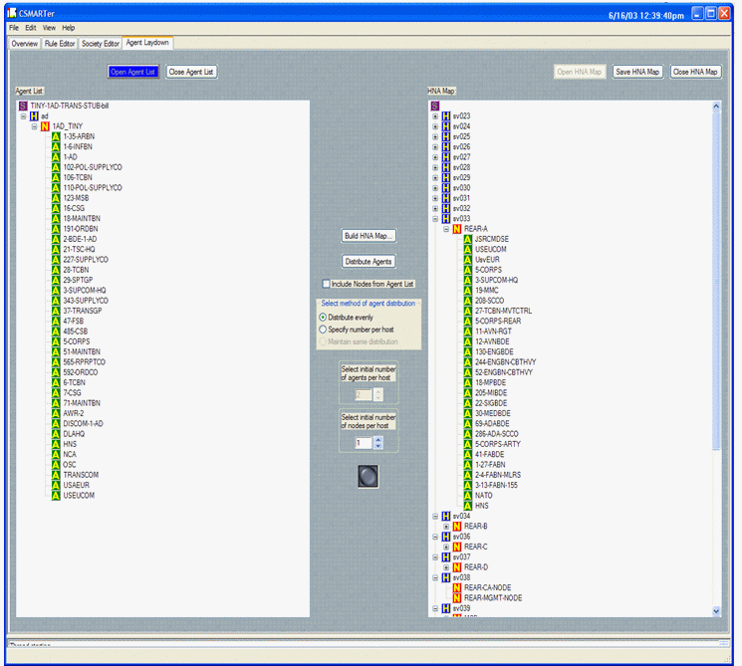

Agent Controller
When a society is ready to be run, you can use the Agent Controller tool to select it and run it.
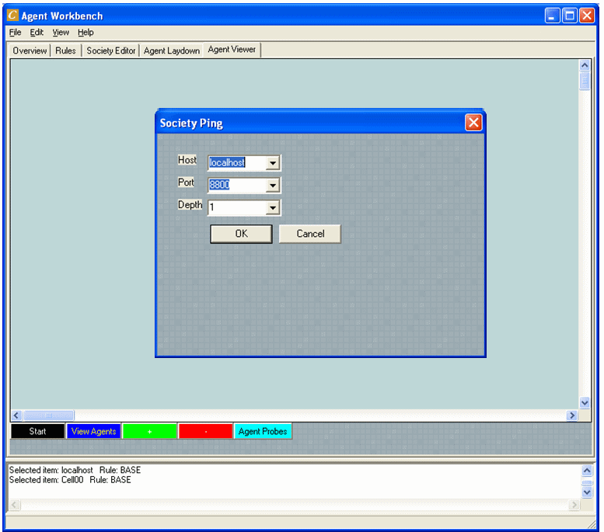
When the GameOfLife society is selected you can then start it and monitor it, using the AgentController. An example servlet that yields information useful in visualizing the society was discussed in the section on Rules Editor.

